Assignment 4: SDN

- Update Ubuntu
sudo apt update && sudo apt upgrade -y
Updates the Ubuntu system.
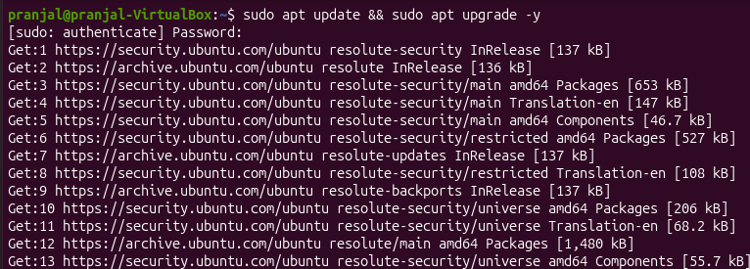

- Install Mininet
sudo apt install mininet -y
Installs Mininet for creating virtual networks.
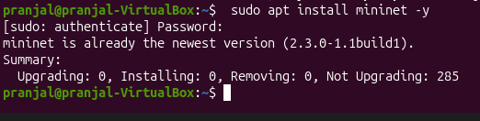

- Install Open vSwitch
sudo apt install openvswitch-switch -y
Installs the software-based SDN switch.
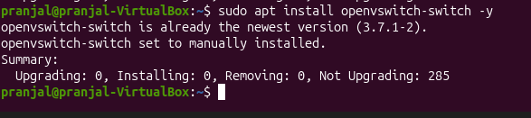

- Check Open vSwitch
sudo systemctl status openvswitch-switch
Checks whether Open vSwitch is running.
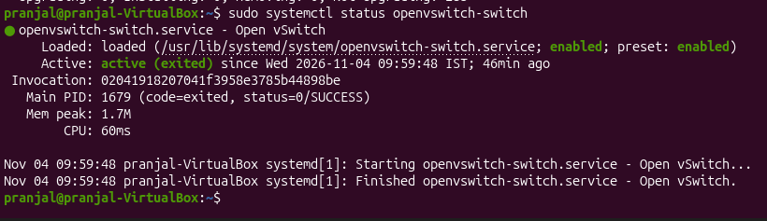

- Test Mininet
sudo mn
Starts a basic Mininet network.
mininet> nodes
Displays the available virtual hosts and switch.
mininet> pingall
Tests connectivity between the virtual hosts.
mininet> exit
Exits Mininet.
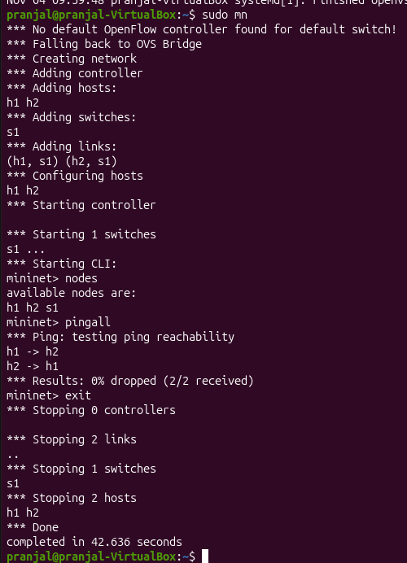

- Install Python and Virtual Environment
sudo apt install python3-pip python3-venv -y
Installs Python package and virtual-environment support.
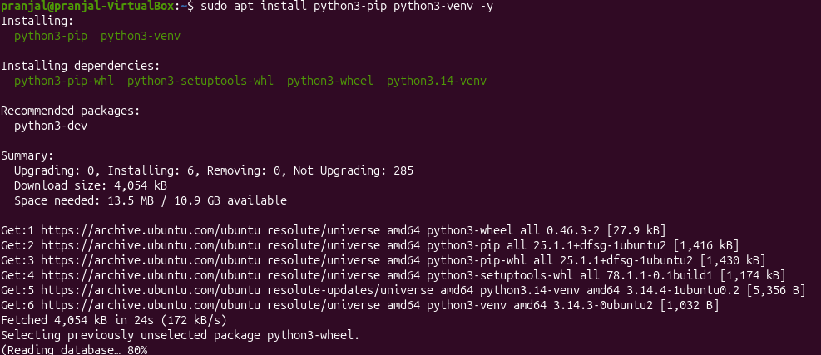

- Create Ryu Environment
uv venv --python 3.9 ryu39-env
source ~/ryu39-env/bin/activate
Creates and activates a Python environment for Ryu.
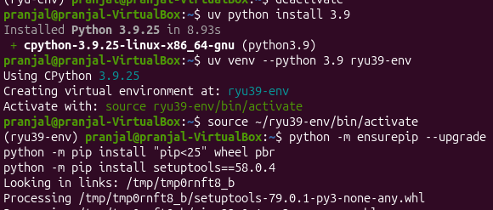

- Install Ryu
python -m pip install ryu
Installs the Ryu SDN controller.
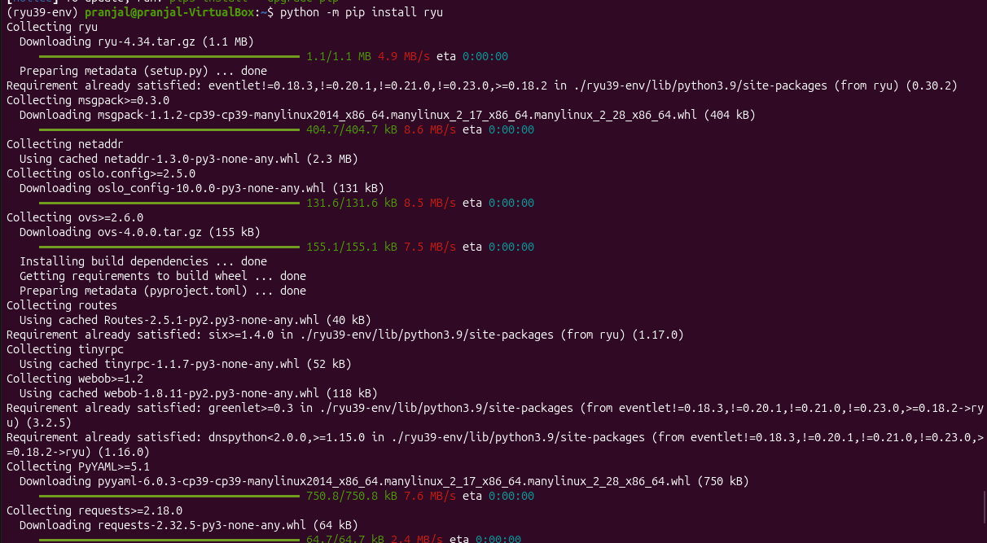

- Test Ryu Installation
ryu-manager --version
Displays the installed Ryu version.
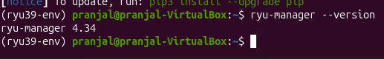

- Start Ryu Controller
ryu-manager ryu.app.simple_switch_13
Starts Ryu with a basic OpenFlow switching application.
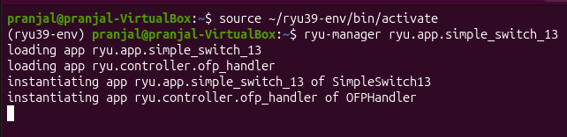
Keep this terminal open.

- Create Mininet SDN Topology
Open a new terminal:
sudo mn --topo single,3 --controller=remote --switch ovsk
Creates 3 virtual hosts connected to an Open vSwitch and remote Ryu controller.
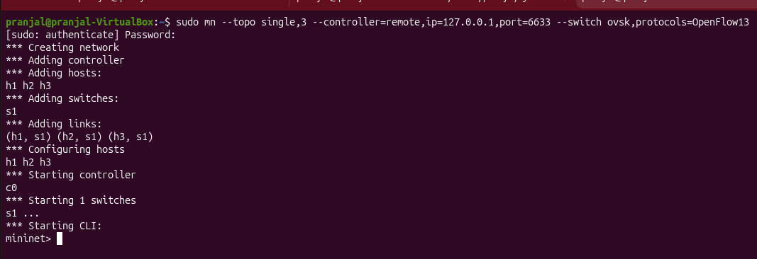

- Check Nodes mininet> nodes
Displays H1, H2, H3 and S1. 13. Check Connectionsmininet>net
Displays the connections between hosts and the switch.
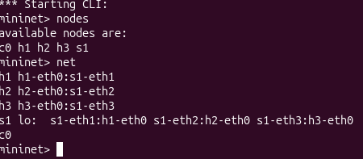

- Test Connectivity mininet> pingall
Verifies communication between all virtual hosts. mininet> h1 ping h2
Tests connectivity between H1 and H2.
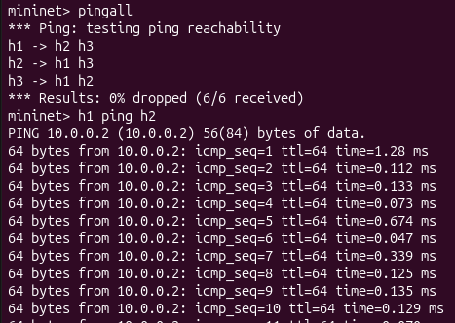

- View Flow Rules Open another terminal: sudo ovs-ofctl -O OpenFlow13 dump-flows s1
Displays the flow rules installed in the Open vSwitch.
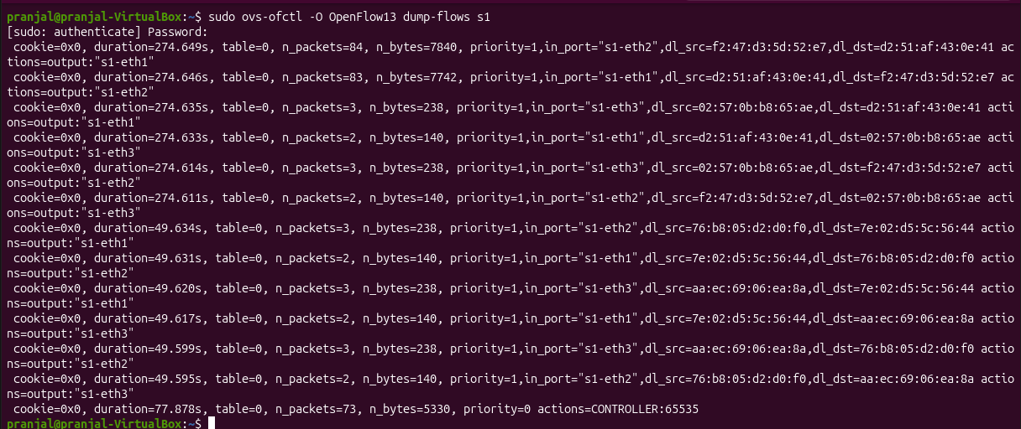

- Add a Simple Filtering Rule sudo ovs-ofctl -O OpenFlow13 add-flow s1 "priority=100,in_port=1,actions=drop"
Drops packets entering S1 through port 1.

- Test the Filtering Rule mininet> h1 ping h2
Checks the effect of the filtering rule on H1's traffic.
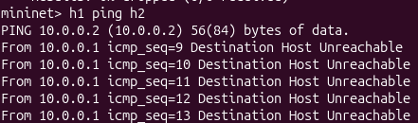
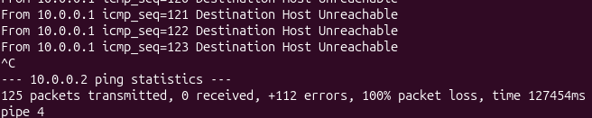

- Remove Flow Rules sudo ovs-ofctl -O OpenFlow13 del-flows s1
Removes the manually added flow rules.

- Clean Mininet sudo mn -c
Cleans up Mininet interfaces and processes.
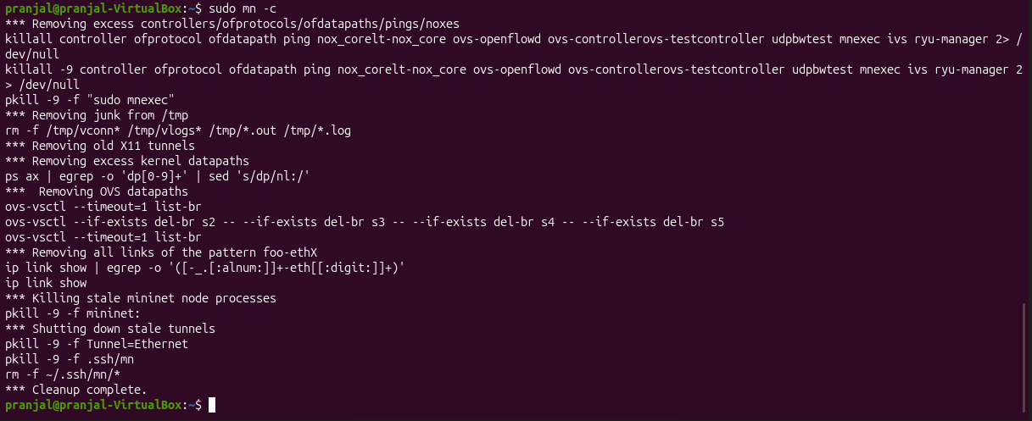
Result
The SDN environment was successfully created using Mininet, Open vSwitch, and the Ryu Controller, and basic forwarding and filtering of network traffic was demonstrated.

